Name(s): | Nisham Karki
Scoring Criteria are available at the Moodle submission site. Use these as a checkoff before you submit your work.

Include images of your results below: These images should be clipped so that they show only the desired results as shown in the lab manual. Insert as much space as you need but keep all text present in this lab sheet intact. Feel free to insert any comments you would like, especially if you did something above and beyond the requirements that you think should be considered for extra credit.

Be sure to check for anything that might generate penalty points as indicated on the submission site.

- Paste a screen shot of the full Tetris window showing at least two previous bricks in position on the gameboard and one current falling brick, all three must be different.

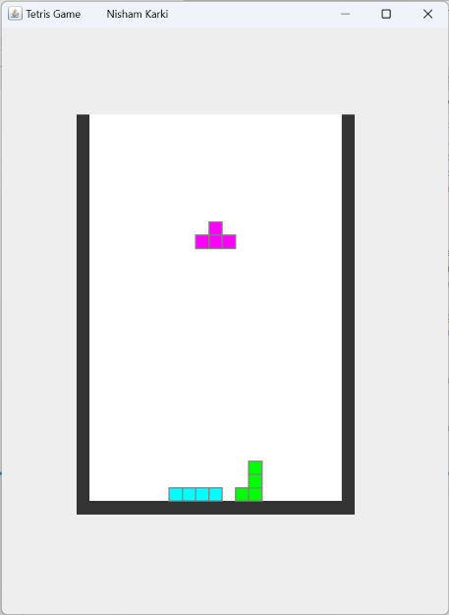

- Paste a screen shot of the full Tetris window showing at least 4 previous bricks in positions on the gameboard both to the right and to the left of the central column of the game board and the current falling brick.

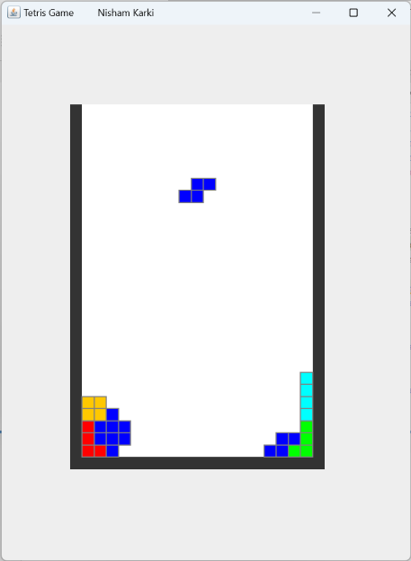

- Paste a screen shot of the full Tetris window showing at least 6 ( at least four different types) previous bricks in position on the gameboard to the right and to the left of the central column of the game board as well as the current falling brick rotated from the initial position. The current brick must be one with asymmetry so that the rotation is obvious.
